Minutes of the Bratton Clovelly Annual Parish Meeting

Held on Wednesday 24th May 2023 **7:00pm** at the School Room, Bratton Clovelly

Present: 12 members of the public, Councillors McNelis, Braidwood, May, Bowyer, Huggins and Gilbert, WDB Cllrs Mott and Southcott and R Ward – clerk

**1.** **Chairman's Welcome** Cllr McNelis welcomed 8 members of the public to the meeting

**2. Apologies**: Carrie Atkinson, the secretary of the PHMC sent her apologies.

**4. Approval of minutes of the last meeting dated 11th May 2022** – *Approved*

**5. Reports from Local Groups/Organisations**:

**Under 5s Playgroup**:

This year started off with some small changes to the Under 5s at Bratton. We now hold our sessions on a Tuesday morning from 9:30-11:30am instead of Mondays at 10am. I prioritised having a large clear out of toys & we organised the playroom at the beginning of year which has resulted in an overall better use of the space by all.

The first half of the year started out as a huge success with us seeing numbers go from 3-4 parents attending a session at the end of last year to 15-20 parents coming each week with their kids. With a big change over we had almost all new members & a lot of babies this year which was great to meet the next generation of kids attending. These numbers continued throughout most of the first half of the year which was a very encouraging start for us. With the increased attendance we were for the first time in a long time covering our costs each week & with money left over we managed to buy some new play mats & bean bag chairs to better support the mums who are attending with little ones who need a comfortable place to sit and nurse.

Unfortunately our numbers have started to decrease by a significant amount since Easter. This is due to a number of reasons including …  mums returning to work, children starting preschool & mums finding other playgroups closer to where they live (this is a big issue as currently none of the mums attending on a regular basis live locally to Bratton so we all drive a significant distance to attend).

We are now in a position where the remaining mums are trying to figure out if Toddlers will continue to run in September. Originally when I attended in past years we always ran toddlers as a joint effort shared amongst all parents. However, this year with a high rate of new parents joining I naturally took on the primary role of running playgroup each week.

I have now informed the mums that moving forward next year I will no longer be able to volunteer my time as I have this year & will be stepping down from my current running of toddlers. We have discussed potentially a rota & trying to spread the responsibilities. Unfortunately there is no current interest from any remaining mums on taking on any commitment on a regular basis which would warrant toddlers remaining running. Sadly this is resulting in a high probability that we will not be able to continue in September.

Of course I am hopeful to find a solution and would be incredibly sad to close down so I will let the hall know as soon as we can about the future of Toddlers at Bratton.

Thank you for your time & support.

Dani Heard

**Bratton Clovelly Badminton Club** report for the Parish Meeting May 2023

Club Play – Every Wednesday 8.00pm to 10.00pm

Venue – Bratton Clovelly Parish Hall

All Standards of play welcome, for beginners to experienced players. Guidance and equipment available.

£2 per session including a hot drink.

Social time, fun and exercise, please come along and enjoy the exercise and the company.

Contact details: Bratton Clovelly Hub, or Margaret Wilson 01837 871248

**Bratton Clovelly Women’s Institute**

Our meetings are held on the 1st Thursday at 7.30 pm of each month in the old Schoolroom by the Parish Church.

There is a yearly programme of speakers, demonstrations, quizzes and games with special events as and when they occur.

Sub groups include gardening and the 4 C’s (Coffee, cake and chat club), also community fund raising.

Our members, mid-teens in number, offer a welcoming, fun filled and sociable experience.

Contacts: Ann Tully 01837 871328 Margaret Wilson 01837 871248

**Parish Clean-Up Report 2023**

On Saturday 15th April 2022 members of Bratton Clovelly community joined together to take part in our Annual Parish Clean-Up.  
The pre-planning went well and advertising the event saw a turnout of a fair number of parishioners. The volunteers collected their Hi-viz jackets, gloves & black bags, received their pick-up routes and headed off, in pleasant weather, in search of offending detritus.

On their return all the rubbish found along the Parish Roads was collected together near the Parish Hall to wait for West Devon collection, (organised by the Parish Council), which was very prompt this year.  
The Event went very well, without any problems, and it is good to say less litter and rubbish was found this year, although the usual spillage from vehicles was evident amongst items found.

Again, it is worthwhile noting that a number of Parishioners have again taken it upon themselves to pick up rubbish throughout the year, as well as on the Clean Up day.

BC Annual Clean-Up Team

**Bratton Clovelly Art and Creative Arts Group**

Annual Report – May 2023

The Art Group is an informal social group that gets together in the main hall on Wednesday afternoons to work on individual projects, share enthusiasm for the creative arts, and, of course, to eat cake. Recently, they have taken advantage of the hall’s newly installed WiFi and are following an online course in creative animal watercolours which has resulted in some stunning horse, dog, and cat portraits to date.

Looking forward, the group are hoping to mount an exhibition and sale of work by themselves and other creatives from the surrounding area in the autumn. This will be accompanied by the offer of afternoon teas.

Thanks must go to Sarah Simpson, who keeps the group records in order, to the organisers and to all the regular attendees, who help to make meetings so welcoming and enjoyable.

Thanks must also to the Parish Hall Committee for keeping the hire fees affordable for this, and other social groups in the Parish, enabling participants to attend for very little outlay. This said, the core membership has dwindled significantly, and the group is just about managing to hold its head above water. But only just and it must expand its numbers if it is to survive.

C Atkinson, for Bratton Clovelly Art Group

**Plant Sale Report**

The annual village Plant Sale was a great success again this year. The Plant Sale has existed for almost 20 years in one form or another and had originally been organised by the Bratton Clovelly Garden Club to raise funds for its own activities. Over the years the monies raised were sufficient to provide support to various charities including Shelterbox, St Luke's Hospice and Jeremiah's Journey, and in 2017 the sale proceeds went towards the erection and maintenance of the light array on the Parish Field to extend DAAT's operational hours into night-time.

When the club folded, the original team continued to organise the event for charitable purposes and, after the restrictions of lockdown, the sale was moved onto the Parish Field where it has been a great success for the last 3 years. Again the weather was kind to us this year and an impressive £1472 was raised which has been distributed equally among St Mary’s Church, Bratton Clovelly, the Friends of Boasley Cross School, Bratton Clovelly Parish Hall and the Devon Air Ambulance Trust

**P3 coordinator –;**

Phil Gilbert and I took on the liaison with Devon County Council (DCC) on the footpaths around the Parish through a scheme called P3…which stands for the ‘Parish Paths Partnership’.

The P3 scheme is an initiative to ensure that the rights of way network is properly maintained and well publicised. It has the support of the National Association of Local Councils and is Devon County Council funded.

The County Council was one of the first 15 Highway Authorities to participate in this scheme, which encourages community involvement and enjoyment of public rights of way. Devon County Council is working in partnership with parish/town councils, landowners and local voluntary groups.

The main aim is to improve the condition of the local rights of way and keep them open and used properly.

There’s a very good website on the Devon County Council website and here is a link to an interactive map where you can search for all paths in Devon - <https://www.devon.gov.uk/prow/interactive-map/>

In Bratton Clovelly Parish there are 14 sections of footpath/bridleway which meander over a distance of nearly 23 kilometers…or just over 14 miles in old money!

Phil and I have met with both the DCC P3 coordinator (Ros Davies) as well as John Baker who is the Public Rights of Way Officer. They both cover a huge patch but are passionate about their roles and nothing has been too much trouble as Phil and I got up to speed.

Phil and I undertake to walk and survey the paths at least annually and there are capital grants that can be sought for major damage. On one stretch we have highlighted significant erosion of a section and DCC are looking to repair this year.

Everyone however can report any issues on the paths to Devon County Council direct through their website. The link is here - <https://www.devon.gov.uk/roadsandtransport/report-a-problem/map/map_src/prow/>.

It takes you through to a map page where you can quickly search for the stretch you are on and then report very easily using the pop-up box which asks what the problem for the x5 different scenarios that are most common.

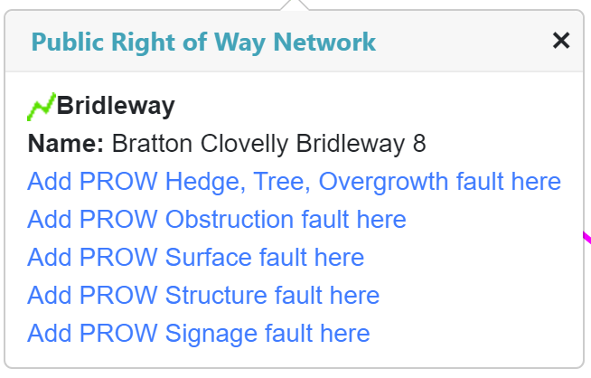

We’re fortunate to have a good network of paths around the Parish and thank you to all those who help take care of them, keep them clean and ensure they are useable for the next user.

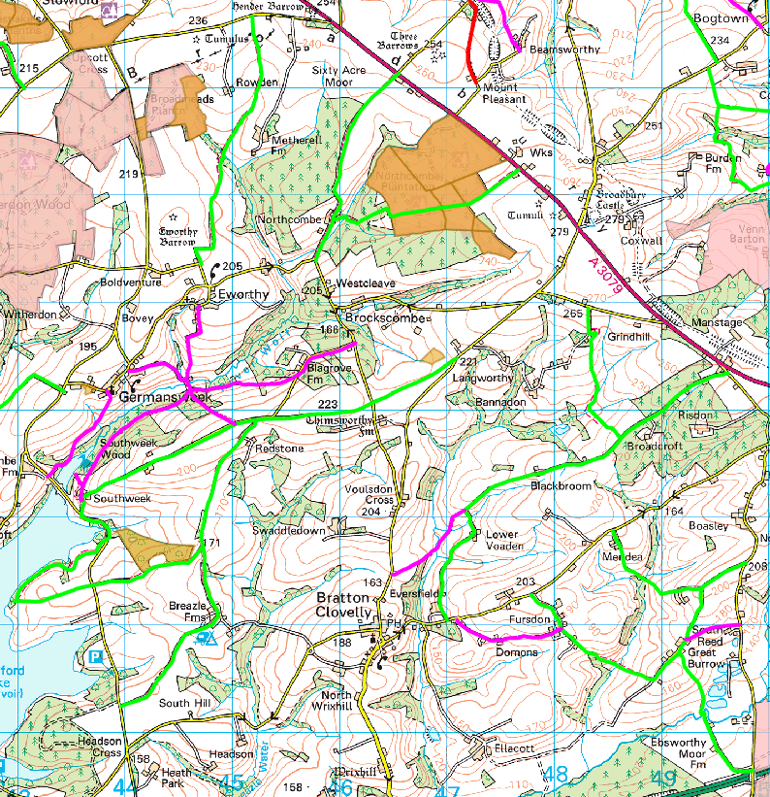

**6. Report from the Parish Council Chairman**

This past year has been pretty extraordinary for the whole country. We have witnessed the passing away of Queen Elizabeth II and her state funeral. We just recently saw the coronation of King Charles III.

Parish Council meetings over the past year have been disrupted by times of mourning and not being quorate. There has been big change in your Councillors. During the year 4 Councillors have resigned: Torben Hughes, Kara Levy, Amy Rocket, and Phil Waters. I thank them for their hard work during previous years and wish them all well. We co-opted 4 new Councillors: Chrissy Bowyer, Colin Braidwood, Kevin Huggins, and Sue May. Welcome to you all! At the recent Local Election all were elected, together with Phil Gilbert and myself. At the Parish Council Meeting which will follow, we shall be co-opting Wendy Jellyman. So, we will be back to ‘normal’ with full complement of 7 Councillors.

If my arithmetic is correct, we have had 9 PC meetings in the past year.

I want to thank the organisers and workers of the Turkey – Syria Earthquake Appeal Dinner in March. This raised over £3,000. I enjoyed the Plant Sale last week and look forward to hearing more about it later in this meeting. There have been other events in the Parish, but I apologise I am not familiar with details (I avoid FaceBook like the plague, so I do not see what goes on the Hub.)

Thank you, all councillors, Clerk Rachel, and volunteers, for your hard work

Thank you everyone for attending.

**7. Parish Council Financial Report FY 2022/23**

During the financial year 2022/23 the Council managed its finances effectively with total precept spend slightly under budget. Staff costs were above budget due to a back-dated local government pay rise. There was also an overspend on Insurance due to unusually high insurance increase, but the Council is now locked in to a three year price freeze. These overspends were more than compensated for by underspends on maintenance, training, and incidentals. The Council was also able to maintain its contingency fund to agreed levels, giving it ring-fenced funds totalling £15964. These are set aside to support spend on contingencies, elections and maintenance, as well as the monies raised to refurbish the playground. There are no further transactions that would have a financial impact on the year end accounting statements.

The budget for 2023/24 was agreed in January 2023 and included an under-inflation rate increase of approx. 5% in the precept. This will fund expected rises in staff costs, an increase to the training budget as we have 4 new councillors and a vacancy. Reductions are planned in Square maintenance, playground (fund raising will take place for this) and expenses/miscellaneous spending to support the increases in other areas.

R Ward May 2023 RFO Bratton Clovelly Parish Council

**8. Questions from the floor -** None

**9. Closure of meeting** 7:28 pm